**Monitor and create a dashboard of machine metrics like cpu , ram etc**

1. Navigate to the terminal of the prometheus machine on the Ubuntu system and execute the following command to download Node Exporter:

**sudo wget** [**https://github.com/prometheus/node_exporter/releases/download/v1.8.2/node_exporter-1.8.2.linux-amd64.tar.gz**](https://github.com/prometheus/node_exporter/releases/download/v1.8.2/node_exporter-1.8.2.linux-amd64.tar.gz)



1. Run the following command to extract the downloaded Node Exporter package:

**sudo tar xvfz node_exporter-*.*-amd64.tar.gz**

**3 . Lets create a new folder with name node_exporter and copy contet of node_exporter-1.8.2.linux-arm64 to that folder to make things easy**

sudo rm node_exporter-1.8.2.linux-**amd64**.tar.gz

sudo mkdir node_exporter

sudo mv node_exporter-*.linux-**amd64**/* ./node_exporter

**4.** Execute the following commands to change the directory and start the node_exporter in the background, redirecting output to **/dev/null**:

**cd node_exporter**

**sudo ./node_exporter > /dev/null 2>&1 &**



**5.** Verify that Node Exporter is running by fetching its metrics with the following command:  
**curl http://localhost:9100/metrics**

**6. we will now go to prometheus directory and in yaml file we will update target as 9100 port**

**cd ..**

**cd prometheus-2.34.0.linux-amd64**

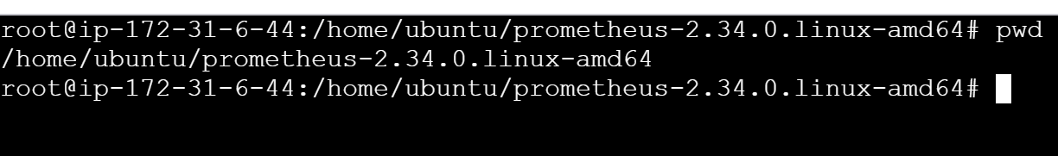

**vi prometheus.yml**

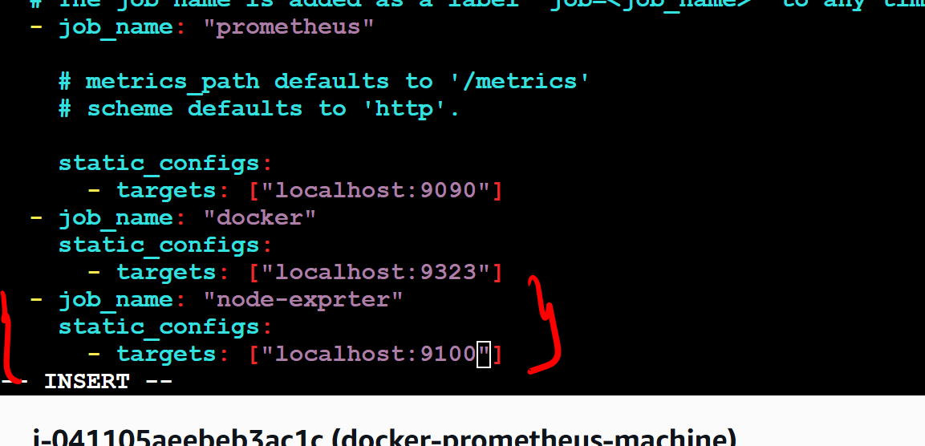

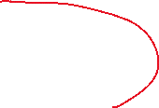

**./prometheus**

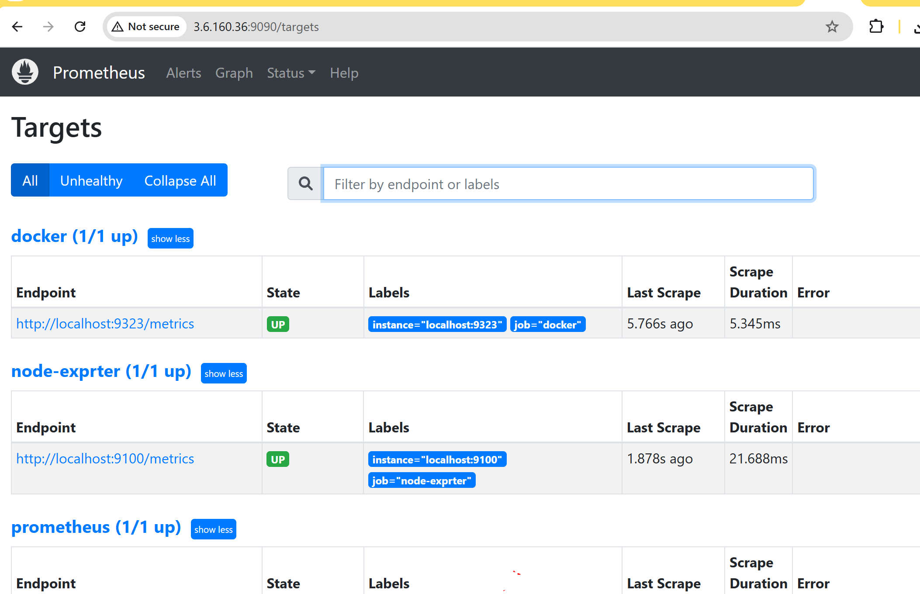

**# lets create a dashboard in Grafana….**

**There is a dashboard by default for node in grafana we can directly import**

